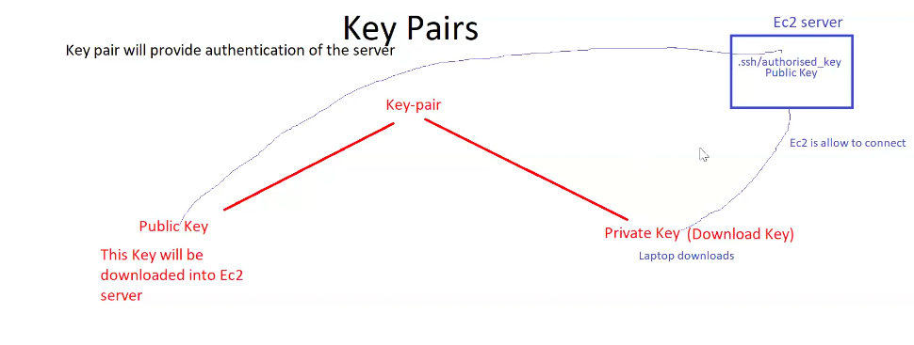

KEY PAIRS

* It will provide Authentication of the server.
* Whenever create a key pair, 2 keys will be generated

1. Private key (downloaded into local laptop).
2. Public key (downloaded into server(EC2)).

For authentication these keys are required.

* In server(EC2), the public key is downloaded into the path folder (.ssh/authorized-key).

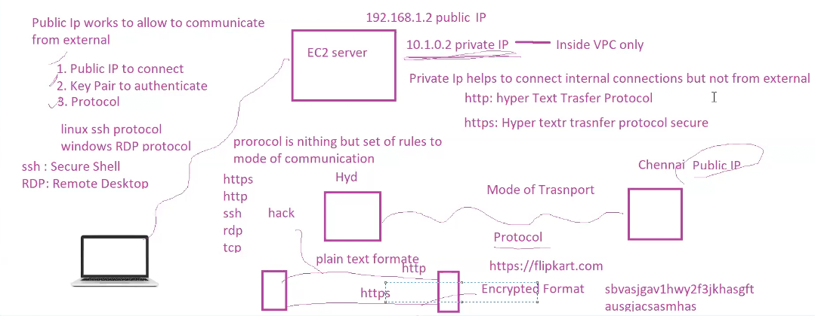

To connect EC2 server for external laptop

1. Public IP to connect.
2. Key pair to Authenticate.
3. Protocol.

IP

For ever server we will get 2 IPs

1. Public IP (Used to connect from external).
2. Private IP (Used in side VPC).

* For connection IP is required.
* For authentication KEY should be required.
* Private IP helps to connect internal connections but not from external.
* Public IP works to allow to communicate from externally.

PROTOCAL

It is nothing but set of rules to mode of communication.

https-----Hyper Text Transfer Protocol Secure

http ------Hyper Text Transfer Protocol

ssh --------Secure Shell (used to connect LINUX)

rdp --------Remote Desktop (used to connect WINDOWS)

tcp ---------Transmission Control Protocol